SRI LANKA INSTITUTE OF INFORMATION

TECHNOLOGY

Information Security Project

The WOLF-CTF box Walkthrough

Dissanayake V.D IT16168114



**Content**

1. Overview
2. Context
3. Goals
4. Process



**Overview**

This project is a web application which has been developed by using python and JavaScript. The application stimulates a social media account which provides the ability view profiles, create chat groups, join existing groups, chat with group members and to share files among them. The intent of this project is to convince the application developers that it’s not only the functionality of the application that matters but the security of that application as well, especially when it’s come to social media accounts.

The player of this CTF box has to follow the instructions, hints given by the WOLF. The WOLF is a black hat hacker. The player (Let’s call him as Alpha), apparently, he is under the control of the WOLF. By exploiting the vulnerabilities of this social media application, the flag is presented to the Alpha at each level. We have recreated the vulnerabilities which had in famous social Medias like Facebook, WhatsApp. This CTF box does not focusing on only the application vulnerabilities but possible social engineering attacks for social media accounts as well.

This is the story board that we have implemented for the Alpha throughout this CTF Box



**Requirements**

Make sure that you have a copy of Python 3.6 or higher installed on your machine. You’ll also need to install pip. If you downloaded Python from Python’s website, you likely already have pip installed (you can check by running pip in a terminal window). If you don’t have it installed, be sure to install it before moving on!

In a terminal window, navigate into the CTFBox-TheWOLF directory.

Run pip3 install -r requirements.txt in your terminal window to make sure that all of the necessary Python packages (Flask and Flask-SocketIO, for instance) are installed.

Set the environment variable FLASK_APP to be application.py. On a Mac or on Linux, the command to do this is export FLASK_APP=application.py. On Windows, the command is instead set FLASK_APP=application.py.

Run flask run to start the Flask application.



**Goals**

The intent of this project is to convince the application developers that it’s not only the functionality of the application that matters but the security of that application as well, especially when it’s come to social media accounts.



**Level 0**

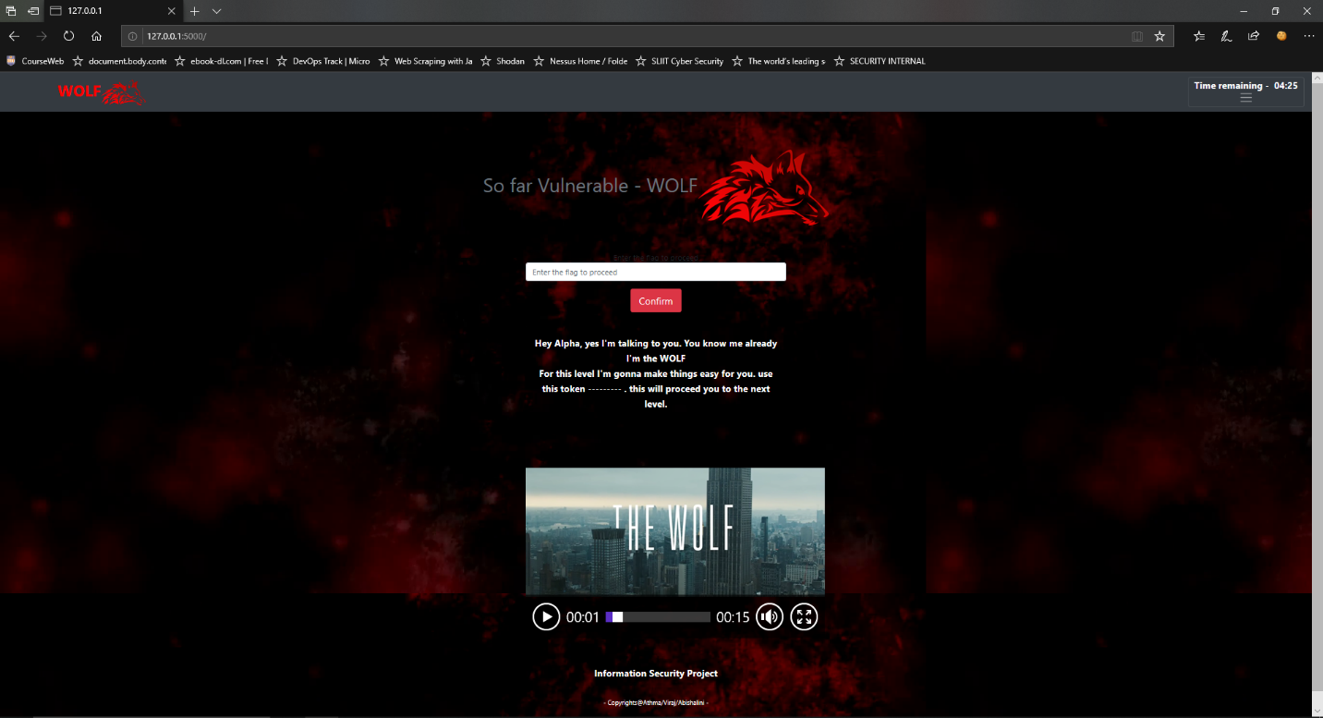

The Level 0 has been designed in a simple way. The player has to identify the hidden html field of the page, which contains the key.

**Level 1**

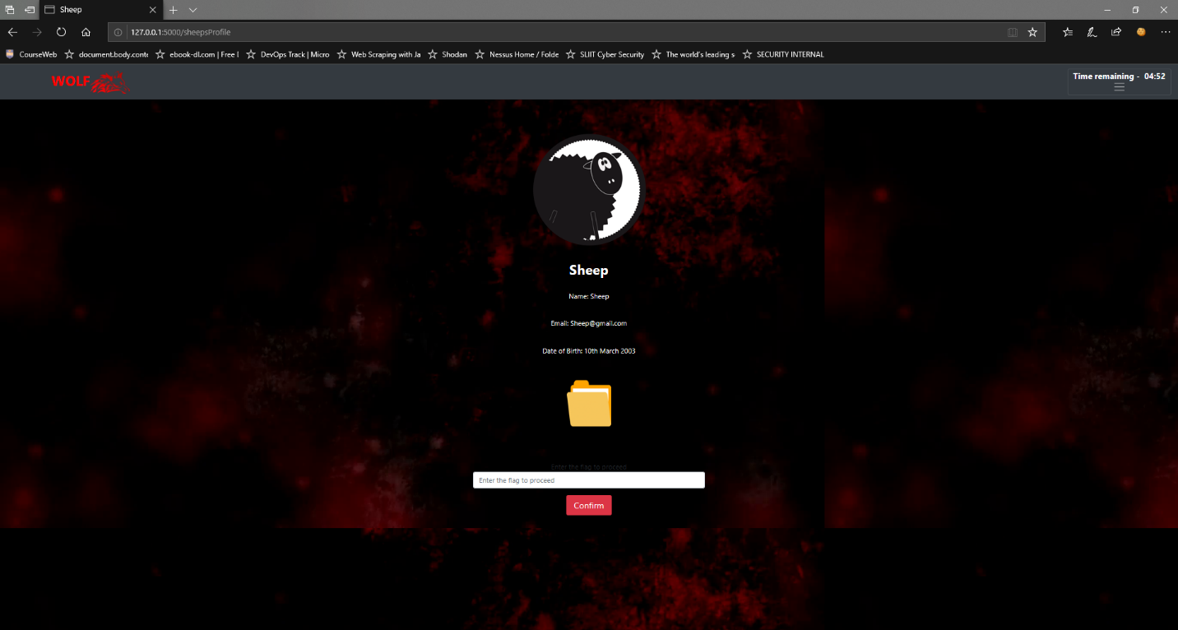

The file extension filtering has been used. The script would not allow the user to download txt files. The player has to bypass this.

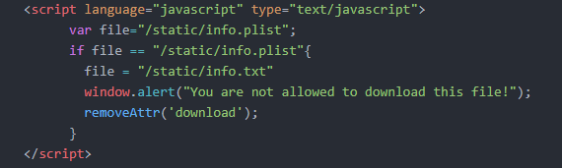

**Level 2**

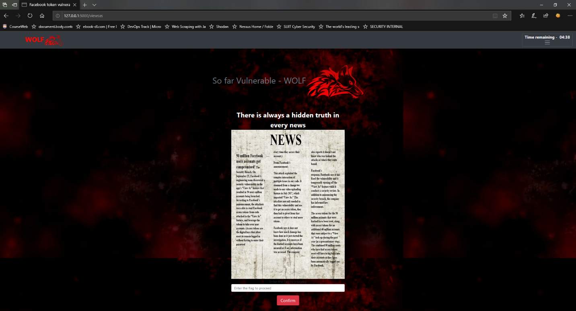

Steganography has been used in this level. The image file contains the key. The content of this becomes the hint for the next level as well.

**Level 3**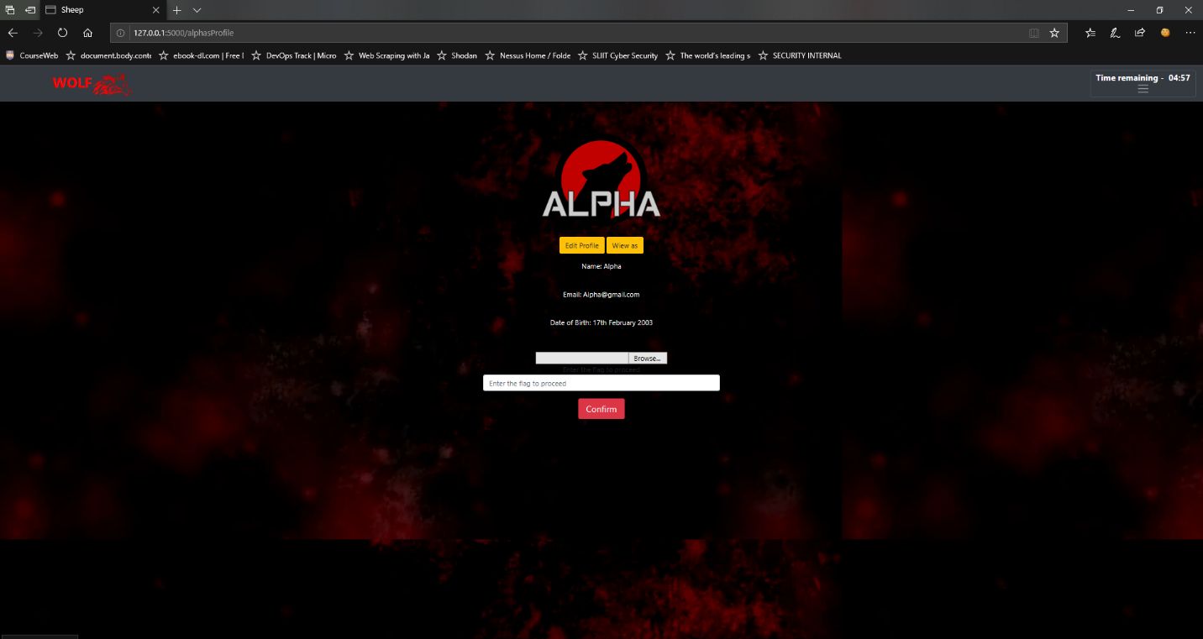

Face book access token vulnerability has been stimulated. The player needs an understanding of the vulnerability in order to perform the attack and gain the key.

**Level 4**

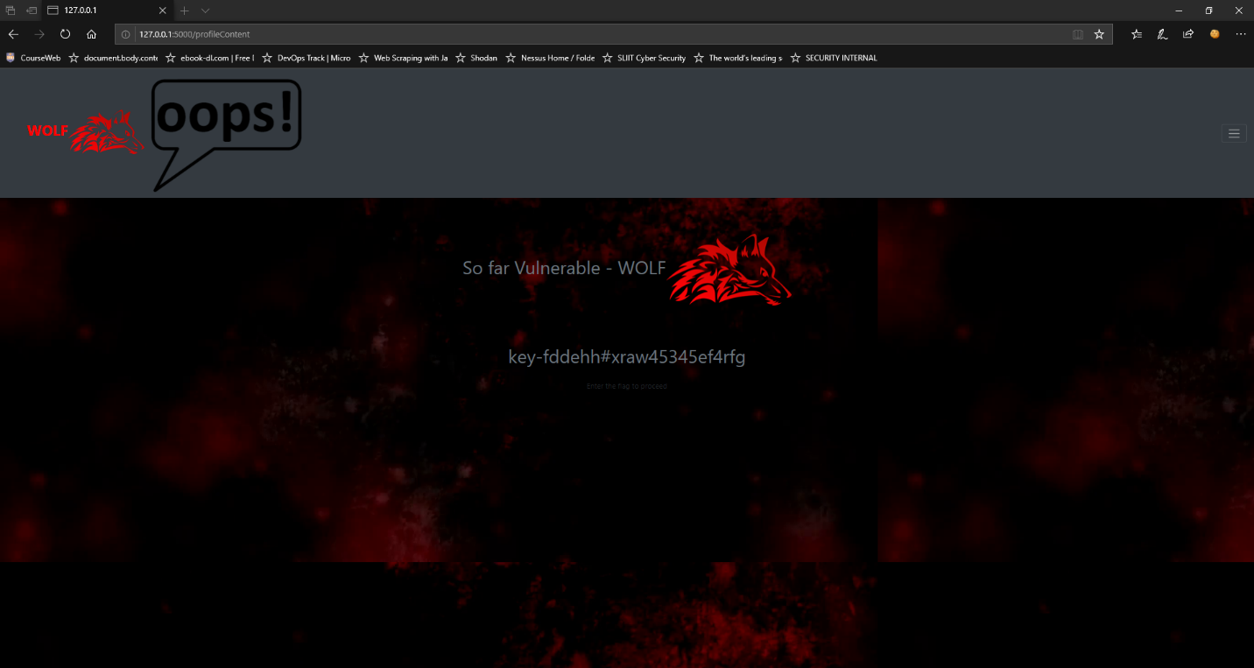

This window will be redirected next window within 0.1 seconds. The player would not be able to see the key displayed in this page.

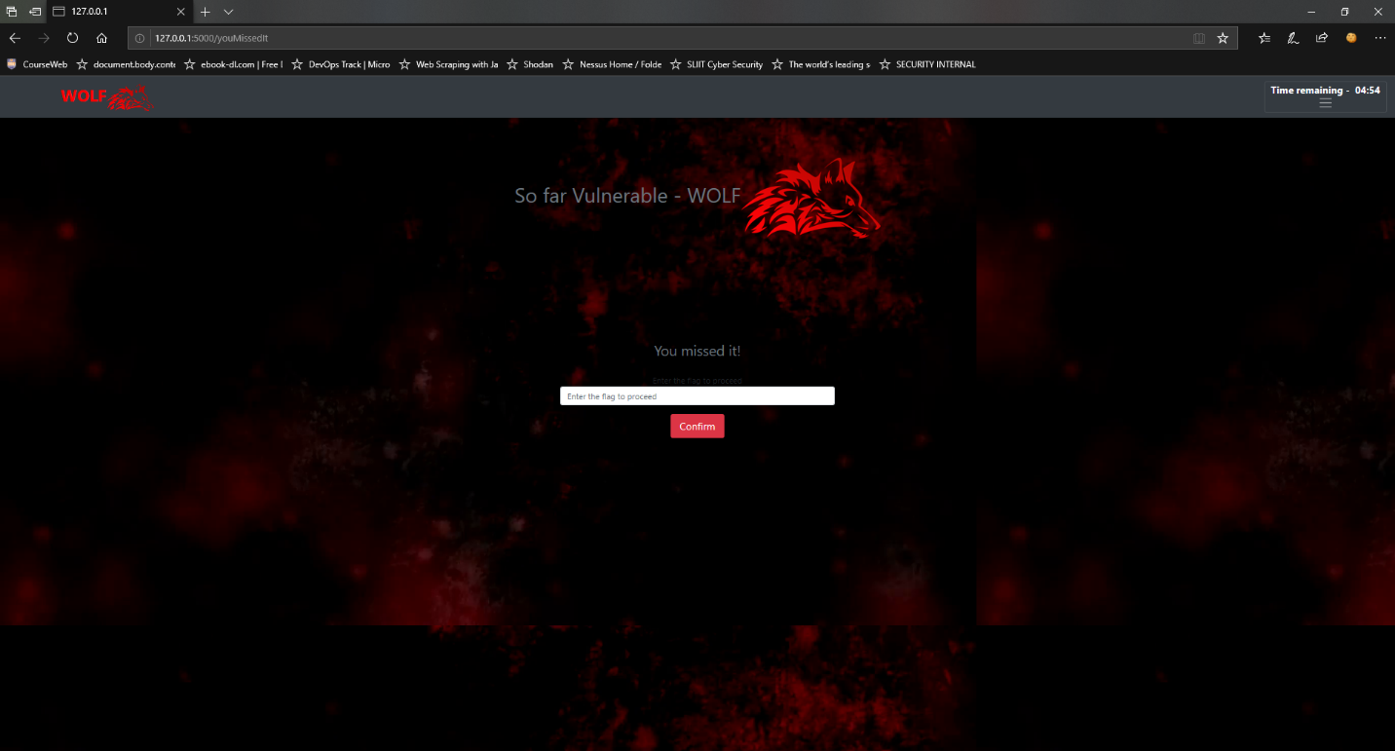

So, the player has to be clever enough to come up with a solution. The expected method to be followed is Web scrapping method.

**Level 5**

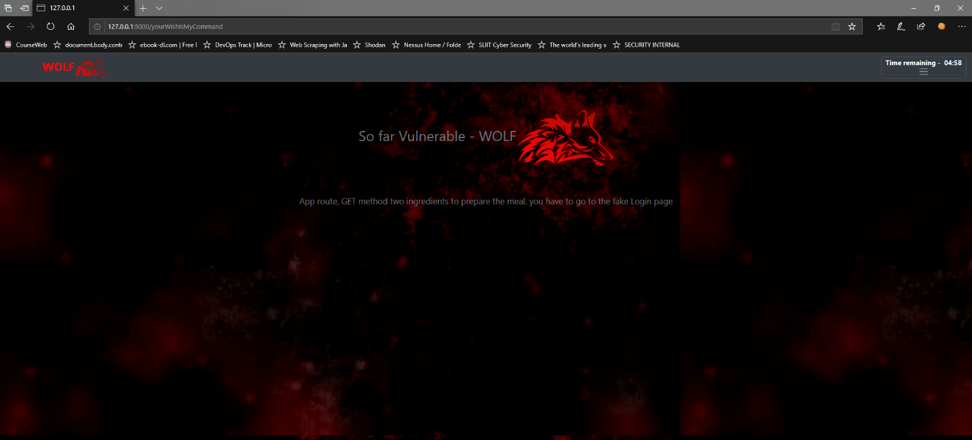

The next route does not use POST method. So, it can be by passed. The player should use /fake Login route to pass to that level

**Level 6**

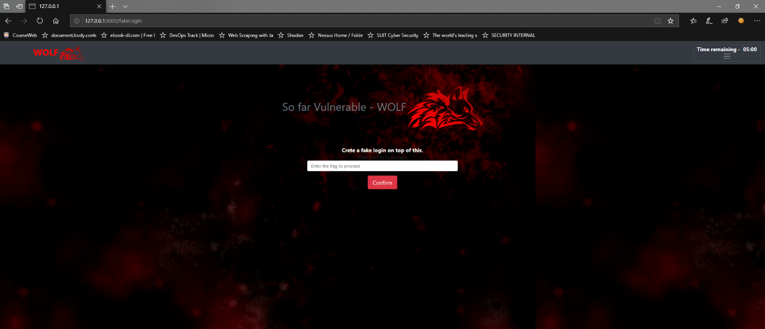

Player has to prompt a fake login on top of this page using a script. This is possible since this page is vulnerable to XSS.

Expected output

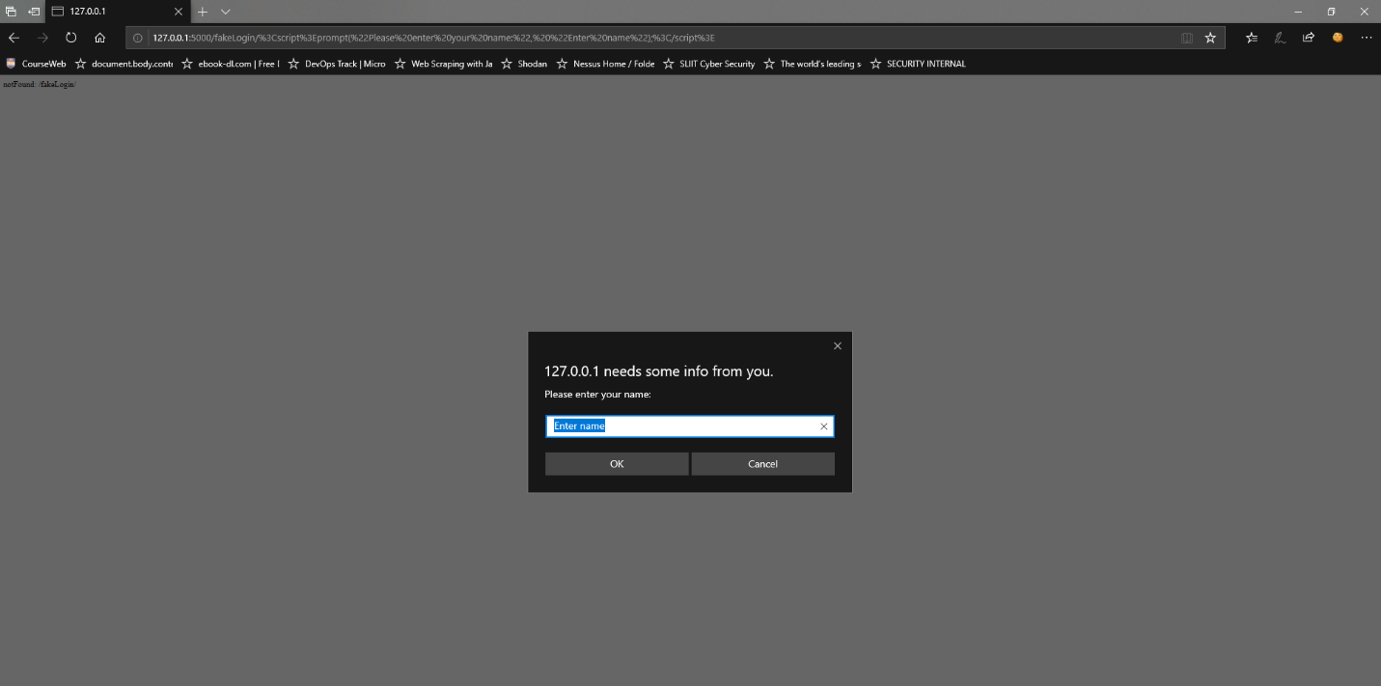

**Level 7**

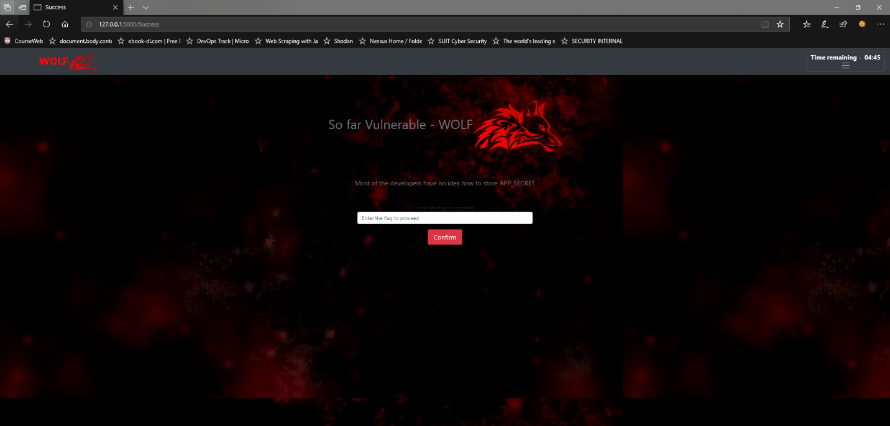

This application creates an environmental variable in runtime. This variable stores the secret key of the app. The player has to retrieve the value of that variable APP_SECRET.

**Level 8**

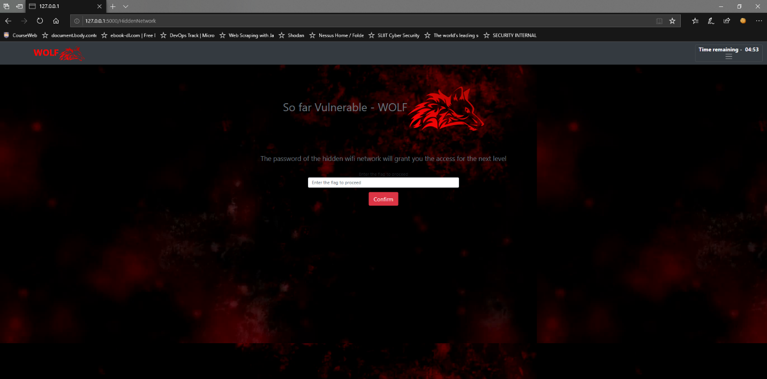

A hidden Wi-Fi network will be displayed to the player. The name of the network will be the key for the next level

**Level 9**

The player has to crack the password of that Wi-Fi network in order to get the key and grant access to the next level



**Level 10**

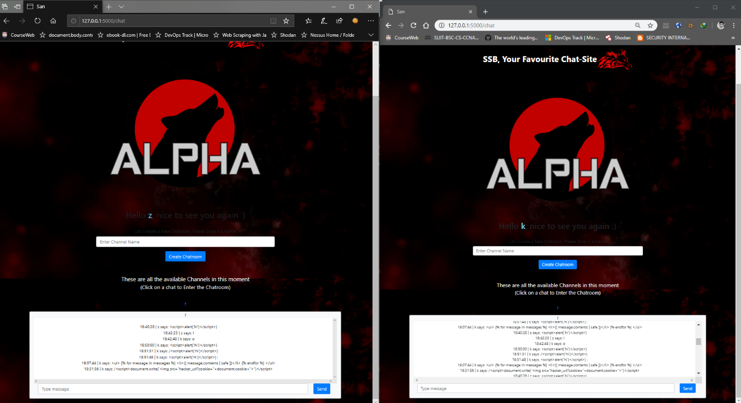

In this level player has to create a chat account in the provided chat app and delete the messages of the user of the other end. This can be done by hacking the login session of the other user. The player is expected to get the session cookie and perform the given task. The value of the session cookie will be the flag for the next level

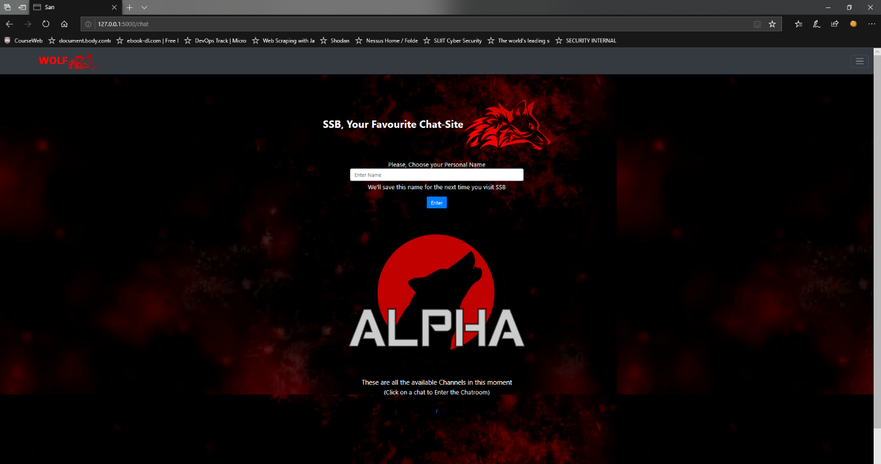

**Level 11**

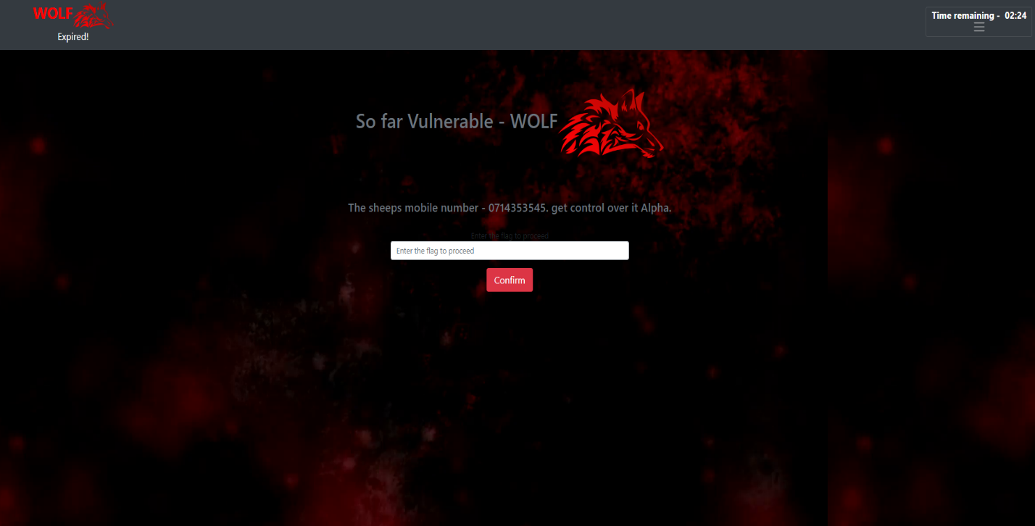

player needs to perform a remote access attack. A phone number of a victim is given. The player is expected to create port forwarding attack and gain access to that phone by sending that link as a SMS to the victim using social engineering.

**Level 12**

In this level AES (Advanced Encryption Standard) is used. Here the right click option is disabled (So cannot get the source code). If the player selects the content of the page and find the secret key for the decryption.

And decode the encrypted format which is attach in the source code and find the next level password. Web scrapping method can be used.

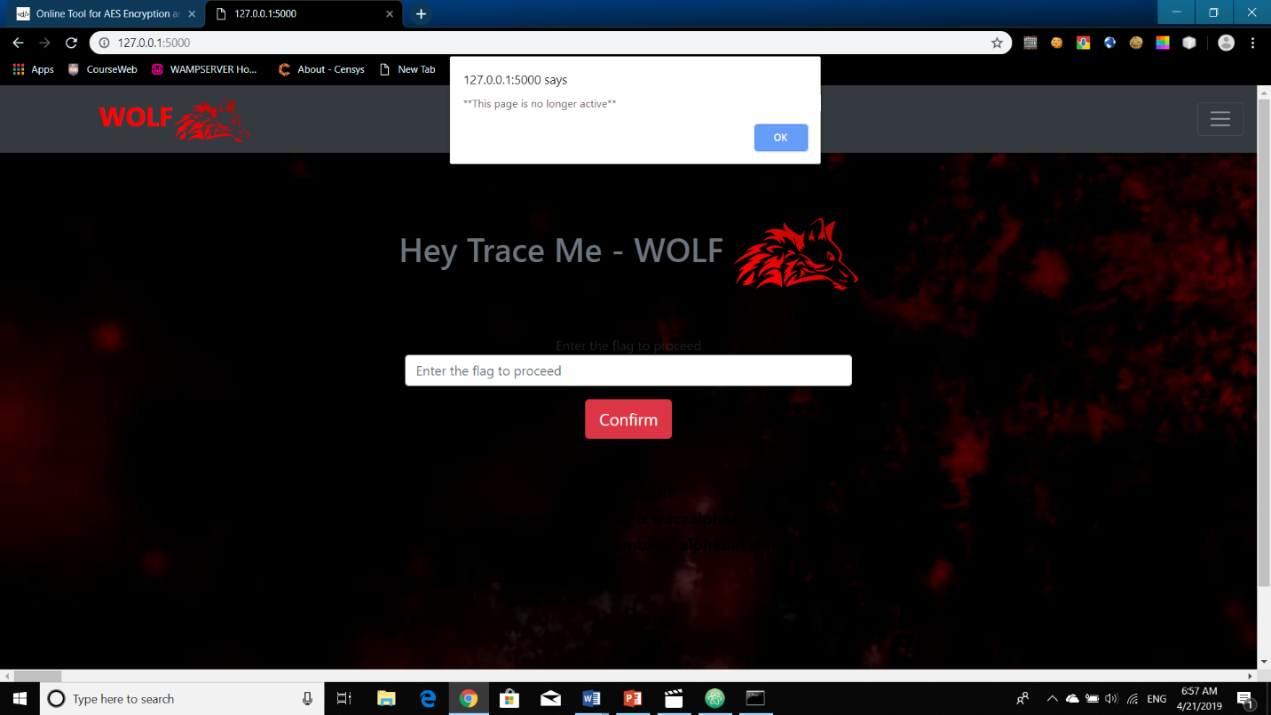

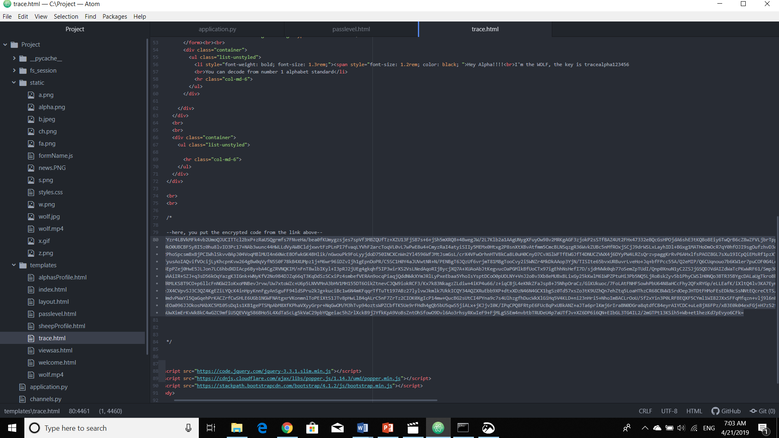

**Level 13**

The knowledge of swift programming is tested. The pasteboard vulnerability of the swift app needs to be exploited in order to retrieve the key for the next level

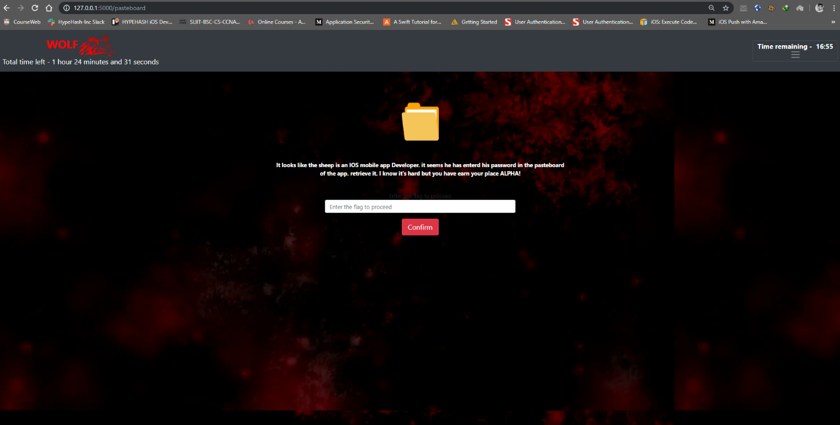

**Level 14**

In this level, alpha can test his reverse engineering knowledge, so first find the unreadable format file and need to convert that one in the readable format. And find the hint for next level.

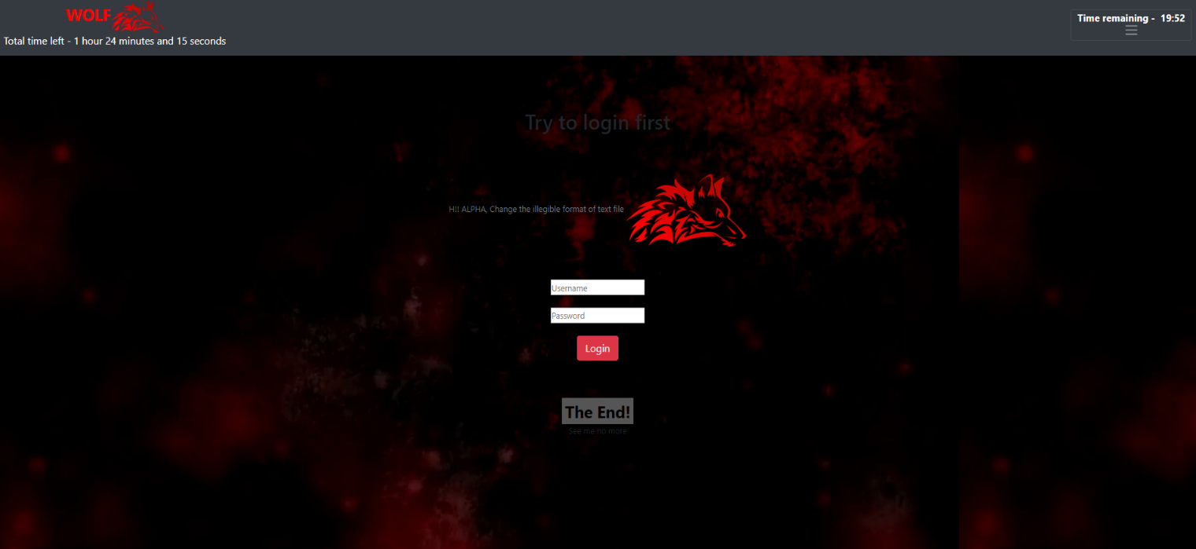

**Level 15**

The Final level contains a challenge that the Alpha needs to create backdoor and get the IP address of the target PC. The IP address that target PC is the key for the last level.



